#Notes

#Exams

#Binding

#Schemes

CALL:

**0703745068/0785681207**

**P.3 SCIENCE LESSON NOTES TERM I SOIL**

Soil is a thin covering of the earth where plants and animals live.

**Components of soil**

Components of soil are things that make up soil.

**Examples of soil components**

1. Living organisms e.g. bacteria
2. Water
3. Rock particles
4. Mineral salts
5. Humus
6. Air

**An experiment to show that soil contains air**

1. Get water in a container/beaker.
2. Get a lump of soil and lower it in a container with water in it as shown below.

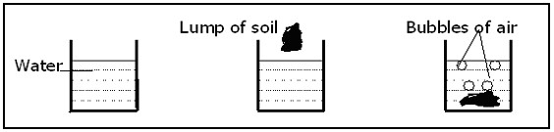

**Observation** Bubbles of air are seen coming out of the soil.

**Conclusion** The bubbles show that soil has air.

**Humus** Humus is the decayed plant and animal remains in the soil.

**An illustration of humus**

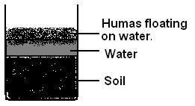

**Uses of humus**

1. Source of plant nutrients.
2. It holds the soil particles together.

**SOIL PROFILE**

Soil profile is the vertical arrangement of soil layers.

1. Top soil
2. Subsoil
3. Bed rock

**Drawing of layers of soil**

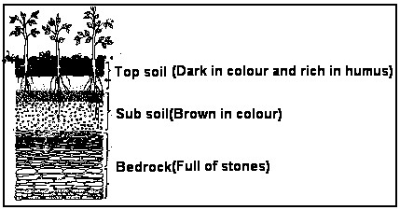

**Types of soil**

1. Loam soil
2. Sand soil
3. Clay soil.

**Properties of soil**

**Loam soil**

1. It is dark in colour.
2. It has medium soil particles.
3. It is a mixture of clay and sand particles.
4. It is the richest in humus.
5. It retains enough water for plant growth.

**Note:**

Loam soil is used for crop growing.

**Clay soil**

1. It has the finest soil particles.
2. It keeps water for a long time.
3. Has small air spaces.

**Note:**

It is used for modeling.

**Sand soil**

1. It has large soil particles
2. It retains very little water.
3. Has large air spaces.

**Note:**

It is used with cement for building.

**Importance of soil(uses of soil)**

* 1. Provides food for the growing plants.
  2. It keeps water for plants.
  3. It contains air that living organisms need.
  4. It holds plants firmly in the ground.
  5. It’s a home for many small animals e .g earthworm etc.
  6. Soil is used for growing crops.
  7. Soil is used for construction.
  8. Soil is used for modeling.

# CHANGES IN THE ENVIRONMENT

There are two changes in the environment. a. Natural changes.

b. Artificial changes.

**Natural changes**

Natural changes are changes in the environment that are not caused by man.

**Examples of natural changes are**; a. Drought

1. Floods
2. Earthquakes
3. Landslides
4. Storms
5. Lightning
6. Thunder
7. Hailstone

**Artificial changes (man made)**

Man made changes are changes caused by mans’ activities.

**Examples of man made changes**

1. Building of roads, houses bridges etc
2. Cutting down trees.
3. Planting
4. Burning bushes.
5. Drilling boreholes.
6. Mining

**Effects of various types of changes to people, animals and plants**

1. People change from young one to old ones and later die.
2. Animals grow old and become useless.
3. Plants grow and later die.
4. Some animals are improved by crossbreeding.
5. New types of seeds are produced after research work.
6. Through research, plants and animals grow and mature quickly.
7. Cutting down trees results into soil erosion.

# SOIL EROSION

Soil erosion is the removal of topsoil by its agents.

**Agents Of Soil Erosion**

Agents of soil erosion are things that help in erosion to take place.

**Agents of soil erosion include the following**:

1. Wind.
2. Running water.
3. Man.
4. Animals.

**Methods of controlling soil erosion** a. Mulching

1. Crop rotation.
2. Planting windbreaks.
3. Terracing
4. Inter cropping.

**Possible ways of managing changes** a. Planting more trees.

1. Preserving swamps.
2. Avoiding burning bushes.
3. Proper farming practices.
4. Covering gullies with stones.
5. Educating people about dangers of cutting trees.
6. Avoiding throwing things which do not rot.

# AIR

Air is a mixture of gases.

**Components of air**

Components of air are gases that make up air.

**Gases that make up air are;** a. Carbondioxide

1. Nitrogen
2. Oxygen
3. Rare gases.

**Uses of different gases**

**Oxygen**

Oxygen is used in:

1. Burning
2. Respiration
3. Germination

**Carbondioxide**

1. It is used to put out fire (extinguish fire)
2. Preservation of foods and drinks.
3. Plants use it in the process of photosynthesis.

**Note** Carbondioxide is used in fire extinguisher because it does not support burning.

**Nitrogen and rare gases**

They are used in making of bulbs.

**An experiment to show that air supports burning**

**Things needed;** a. Candle

1. Matchbox
2. Glass cup

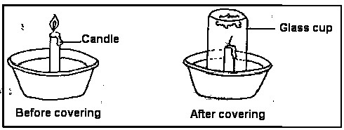

**Observation**

1. The flame burns for a short time then goes off (out)
2. The flame goes out because there is no more oxygen to support it burning.

**Conclusion**

Air supports burning.

**Note** the part of air that supports burning is oxygen.

**Properties of air**

1. Air exerts pressure
2. Air has weight.
3. Air can be compressed.
4. Air occupies space.

**Experiment to show that air exerts pressure** Things needed a. Glass cup.

1. Water
2. Cardboard paper.

**Steps**

1. Fill a glass cup with water
2. Cover the filled glass cup with the card paper.
3. Turn the glass cup upside down:

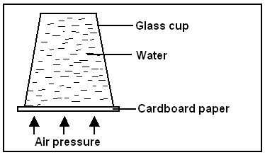

**Observation** The card paper does not fall off because air is exerting pressure on it.

**Experiment to show that air occupies space**

Things needed;

* 1. Glass cup
  2. Basin
  3. Water.

**Steps**

* 1. Put water in a basin.
  2. Turn the empty glass upside down and lower it into the water.
  3. Tilt the glass cup slightly.

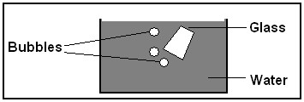

**Observation** The air bubbles seen (observed) shows that air was in the glass.

**Experiment to show that air has weight**

Things needed

* 1. Bean balance
  2. 2 Balloons
  3. Pin.

**Steps**

1. Fill the balloons with air.
2. Then tie a balloon on each side of the beam balance
3. Prick one balloon with a pin to remove air.

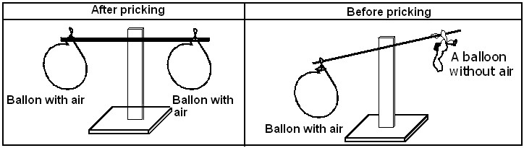

**Observation**

1. The balloon with air moves down wards to show that it is heavier.

**Air can be compressed**

Drawing of an object with compressed air.

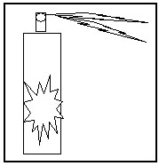

Some other things where compressed air is used are: a. Gas cylinders.

* 1. Playing balls
  2. Tubes in bicycle/motorcycle tyres and car tyres.

**General uses of air**

1. Air is used during burning.
2. Air is used during respiration.
3. Air is used during germination.
4. Air is used during photosynthesis.
5. Air is used in putting out fire.
6. Air is used during preserving tinned food and drink.

# WIND

Wind is moving air.

**Uses of wind**

1. Wind is use to run boats.
2. Wind is used to run machines e.g. windmills
3. Wind is used for winnowing.
4. Wind dries our clothing.
5. Wind helps in pollination
6. Wind helps in seed dispersal

**Dangers of wind**

1. Strong wind blows off roofs of houses.
2. Strong wind destroys crops and trees.
3. Wind blows away topsoil.
4. Strong wind slows down the speed of moving objects.
5. Strong wind capsizes boats.
6. Spread diseases.

# THE SUN

The sun is the main natural source of light.

**Uses of the sun**

1. Sunlight gives us light.
2. Plants use sunlight energy to make their own food.
3. The sun is a source of vitamin D.
4. We get solar energy from the sun.
5. The sun is important in rain formation.
6. The sun heat dries seeds, clothes, crops etc.
7. Flying kites

**Dangers of the sun**

1. Looking at the sun directly spoils the eyes.
2. Long periods of sunshine dry up water sources.
3. A long period of sunshine causes droughts.

# LIGHT

Light is a form of energy that enables us to see.

**Sources of light**

1. Artificial source
2. Natural sources

**Natural sources of light**

Natural sources of light are sources created by God.

**Examples of natural sources of light are**: a. The sun

1. The stars
2. Glow worms.
3. Fire flies
4. Erupting volcanoes.

**Artificial source of light**

Artificial sources of light are sources of light made by man.

**Examples of artificial sources of light are**: a. Torch

1. Paraffin lamp
2. Gas lamp.
3. Electric lamp
4. Fire

**SHADOWS** Shadows are formed when a light falls on an opaque object.

**Diagram showing a shadow of a tree**

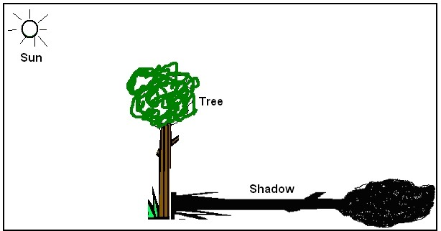

**Note** Shadows are usually formed in the opposite direction of the source of light.

**A diagram showing parts of a shadow**

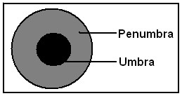

**Appearances of a shadow at different times of the day**

**Morning**

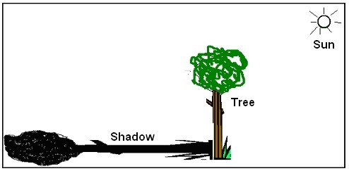

**Noon**

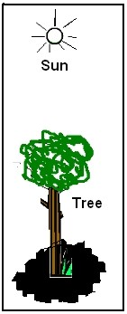

**Note:**

Shadows appear shortest at noon because the sun is directly above an object.

**Evening**



**OBJECTS**

There are three kinds of objects. a. Opaque objects.

1. Transparent objects.
2. Translucent objects.

**Opaque objects** Opaque objects are objects that do not allow light to pass through them.

**Examples of opaque objects**; a. Concrete

1. Wood
2. People

**Transparent objects**

A transparent object is an object that allows all light to pass through them.

**Examples of transparent objects**. a. Clear Glass

1. Clear polythene.
2. Clear plastic rulers. **Translucent objects** Translucent objects are objects that allow little light to pass through them.

**Examples of translucent objects**. a. Coloured polythene paper.

b. Tracing paper.

**THE WATER CYCLE** Water cycle is the process by which rain is formed.

**Diagram showing the process of water cycle**

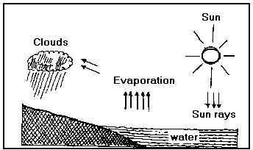

**Explanation**

1. The sun heats the water body.
2. The water changes/turns into water vapour and rises.
3. The rising vapour cools down to form clouds.
4. Clouds release the water in form of rain.
5. When water reaches the ground, it drains (enters the soil) and some flows back to the water body.

**Note**

**Evaporation**

This is a process through which water changes into vapour on heating.

**Condensation** This is a process through which vapour turns into liquid on cooling.

**Transpiration**

This is a process through which plants lose water vapour into the atmosphere.

**A diagram illustrating transpiration**

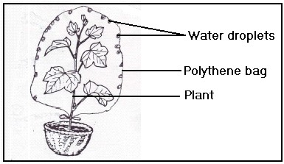

**An experiment to demonstrate rain formation** Things needed are; a. Kettle

* 1. Trough
  2. Stove
  3. Container with cold water.
  4. Water.

**A diagram illustrating rain formation**

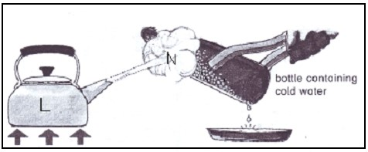

Processes in the above experiment L is evaporation.

N is condensation.

**Note:**

1. The charcoal stove represents the sun.
2. The kettle represents the water body.
3. The condensed water on the cold bottle represents the clouds.
4. The drop of water represents rainfall.
5. The surface of the container with cold water represents the condensation point.

**Dangers of rain in the environment** a. It causes floods

* 1. It leads to soil erosion.
  2. Stormy rain destroys lives and property.
  3. It leads to landslides in hilly places.

**Advantages of rain in the environment** a. Reliable rain supports plants growth.

b. Fills water bodies with water.

# WATER

There are two types of water sources a. Natural sources.

b. Artificial sources.

**Natural sources**

The main natural source of water is rain.

**Other sources of water are** a. Oceans

1. Rivers
2. Lakes
3. Seas
4. Streams

**Artificial sources** a. Bore holes

1. Wells.
2. Ponds.
3. Valley dams

**Uses of water**

1. Water is used for cooking.
2. We drink water.
3. Water is used for washing.
4. Water is used for watering plants.
5. Water is used for bathing.
6. Water is also a habitat (home) for some plants and animals.

**Uses of water bodies** a. Fishing

1. Transport
2. Swimming
3. Formation of rainfall.

**Harvesting water.**

Water is harvested using; a. Saucepans

1. Jerrican.
2. Pots
3. Tanks

**Ways of making water safe for use** a. Through boiling.

b. Through chemical treatment.

**Dangers of water**

1. Too much water causes flood.
2. Too much water destroys our crop.
3. Running water carries away topsoil.
4. Water habours germs that cause diseases Like typhoid, cholera, dysentery.
5. Stagnant water is a breeding place for mosquitoes.

**Ways of protecting water sources** a. Fence the water sources.

1. Regular cleaning of the water sources.
2. Covering open wells.

# CLOUDS

1. Clouds are masses of water droplets floating in air.
2. Clouds usually tell us what the weather is like. The people who study weather are called **meteorologists.**

**Types of clouds**

1. Nimbus clouds are a sure sign of rain.
2. Cirrus clouds look like feathers and they are the highest.
3. Stratus clouds are the indicators of bad weather.
4. Cumulus clouds look like bales of cotton wool

**Uses of clouds**

1. Clouds cover us from direct sun heat.
2. Clouds cool down the temperature.
3. Clouds bring rain.
4. Clouds help us to predict the type of weather.

**Effects of clouds on weather** a. Clouds bring rain.

1. Clouds bring about changes in temperature.
2. Clouds lead to thunder and storms

**Note:**

1. Temperature is the degree of hotness or coldness of the day.
2. Temperature is measured using a thermometer.

**TERM II**

**THE ENVIRONMENT**

**SCIENCE**

1. Science is the study of living and non-living things
2. Living things and non-living things are found in our environment.
3. Environment is our surrounding.

**Our environment**

Things in our environment are put into two major groups namely: a) Non-living things.

b) Living things.

**Non-living things**

1. Non living things are things without life.
2. Non-living things are also divided into two groups namely:
   1. Natural non-living things.
   2. Artificial non-living things.

**Examples of non-living things:**

## Natural Artificial

a Water a Car b Soil b Ship

c Hills c Buildings

**Living things**

1. Living things are things with life
2. Living things are also divided into two groups namely:
   1. Plants.
   2. Animals.

## Plants Animals

a Mango plant a Cockroach b Banana plant b Cows c Rose plant c Man

d Paw paw plant d Sheep

**Characteristics of living things.** a. Living things breathe.

1. Living things Move.
2. Living things grow.
3. Living things feed.
4. Living things reproduce.
5. Living things pass out waste.
6. Living things respond to stimuli.

**Breathing**

1. Breathing is the taking in and out of air.
2. Animals require oxygen and release carbondioxide.
3. Plants require carbondioxide at day time and release oxygen.
4. Plants require oxygen at night time and release carbondioxide.

**Waste products.**

Waste products are poisonous things that need to be removed from plants and animal bodies.

**Animal waste products are**:

* 1. Urine
  2. Sweat
  3. Carbondioxide
  4. Faeces

**Waste products of plants are**: a) Oxygen at daytime.

b) Carbondioxide at nighttime.

**Why animals move.** a. To look for Food

* 1. To look for Shelter
  2. For Protection.
  3. To look for their young ones
  4. To look for Jobs in case of people.
  5. To look for their mates.

**ANIMALS IN OUR ENVIRONMENT**

**Animals in and around our school compound**

**Animals with no legs.** a. Worms

* 1. Snakes
  2. Snails
  3. Slugs

**Diagrams of Animals with no legs**

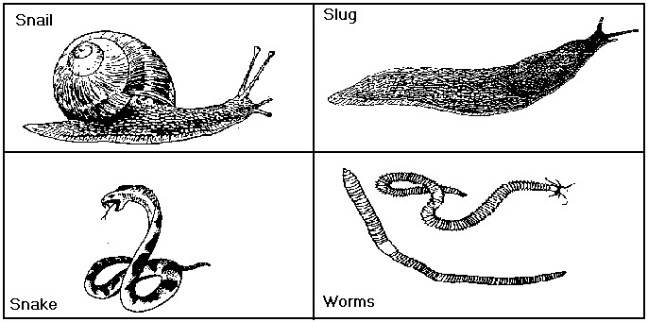

**Animals with two legs.** a. Birds

b. Man

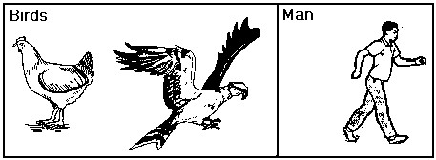

**Animals with four legs**. a. Dog

1. Cat
2. Cow
3. Pig etc

**Diagrams of Animals with four legs**

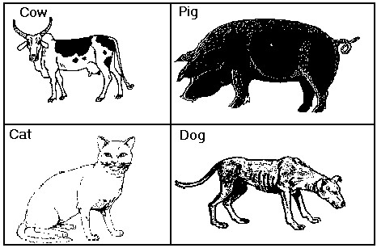

**Where some animals live**. a) A cow lives in a kraal

1. A dog lives in a Kennel.
2. A bee lives in a bee hive
3. A rabbit lives a hutch

**What these animals eat**. a) A cow eats grass.

1. A dog eats flesh.
2. A bee eats nectar
3. A rabbit eats green vegetation.

**Animals with eight legs**. a. Ticks

1. Scorpion
2. Spider
3. Lobster
4. Crab

**Diagrams of animals with eight legs**;

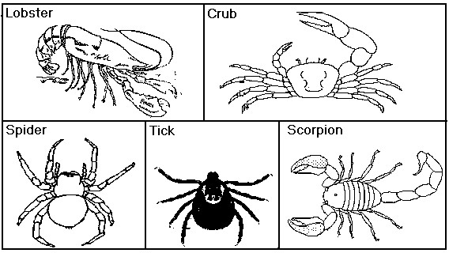

Spider and a tick are the best examples of animals with two main body parts.

**Animals with more than eight legs.** a. Millipede

1. Centipede
2. Wood louse

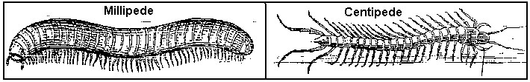

**Animals with six legs**.

Animals with six legs are generally called insects.

**Characteristics of true insects**.

1. True insects have three main body parts.
2. True insects have six legs.
3. True insects have compound eyes.

**Examples of true insects.** a. Bees

1. Tsetse fly
2. Butterfly
3. Housefly
4. Cockroach
5. Wasp
6. Termite

**External parts of a housefly**.

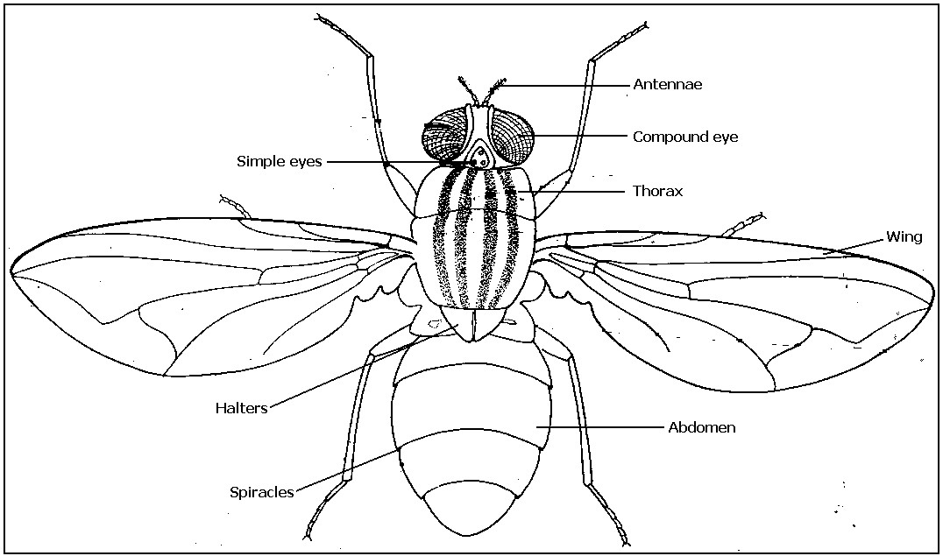

1. The legs and wings of an insect are attached to the thorax.
2. Insects use spiracles for breathing.

**What different animals feed on:**

* 1. Termites feed on dead plant material.
  2. Grasshoppers feed on grass.
  3. Butterflies feed on nectar.
  4. A housefly feeds on juice from rotting matter.
  5. Cockroach feeds on paper and leftover food.

**Note:**

A housefly uses a proboscis for sucking juice from rotting matter.

**The lifecycle of a housefly.**

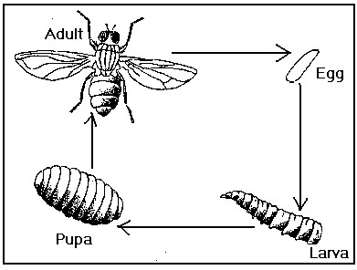

1. A housefly passes through four stages of development (growth)
2. The four stages of growth is called complete (metamorphosis) or life cycle.
3. A housefly lays eggs in warm dump places. e.g in decaying (rotting) matter.

**External parts of a cockroach.**

Parts labeled are:

* 1. Feeler. f. Wing.
  2. Leg. g. Abdomen.
  3. Compound eye. h. Segment.
  4. Head. i. Spiracle.
  5. Thorax.

**Life cycle of a cockroach.**

1. The cockroach has three stages of growth i.e. Eggs, nymph and Adult.
2. The three stages of growth are called incomplete metamorphosis (life cycle that doesn’t pass through four stages of growth).
3. A cockroach lays eggs in dark warm places. **Diagram of the structure of a cockroach**

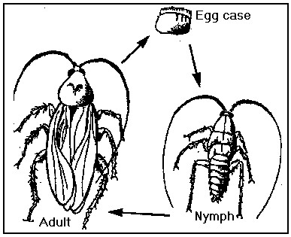

**Social insects.**

* 1. Social insects are insects that work and live together.
  2. Insects that live and work together live in colonies.

**Examples of social insects** a) Termites

* 1. Bees
  2. Wasps
  3. Safari ants.

**Houses of insects that live in colonies**.

* 1. Bees - hive.
  2. Termites - mound
  3. Black wasps - nest

**Bees**

1. Bees are social insects that live in colonies.
2. One colony of bees lives in a beehive.
3. Bees lay their eggs in combs.
4. Combs are made of wax.
5. Bees feed on nectar.
6. A queen bee and a drone are the only fertile insects in a bee colony.
7. Excess nectar is stored as honey.
8. The worker bee is sterile (infertile)
9. There are three types of bees in a colony.

**Pictures of the types bees**

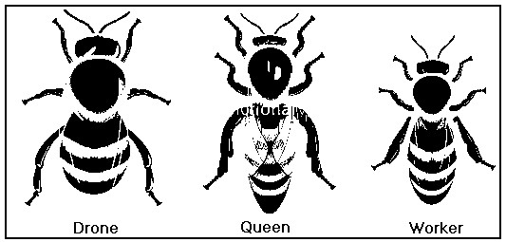

**Termites:**

Termites are social insects.

They live in a termite mound.

**Types of termites**

1. Soldier termites
2. King termites
3. Queen termite
4. Winged termite
5. Worker termite.

**Diagram of types of termites.**

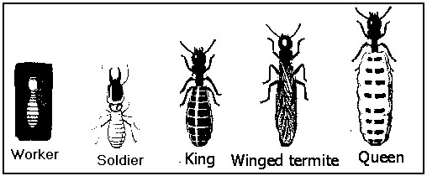

**Functions of each termite in a mound.**

1. King termite fertilizes the eggs of a queen.
2. Queen termite lays eggs.
3. Soldier termite defends or guards the mound.
4. Winged termites develop into queens or kings after the wedding flight.
5. Worker termite collects food and builds the mound.

**Solitary insects**

Solitary insects are insects that move and stay alone.

**Examples of solitary insects.** a. Houseflies.

1. Cockroaches.
2. Mosquitoes.
3. Butterflies. etc

**Water animals** These are animals that live in water most of their lifetime.

**Examples of water animals**

1. Crab
2. Fish
3. Crocodile
4. Hippopotamus
5. Octopus
6. Water Snails Frogs

**Different types of fish**

1. Mud fish
2. Lung fish
3. Tilapia
4. Shark
5. Cart fish
6. Herring
7. Silver fish
8. Nile perch **Note.**
9. A Young fish is called a fry.
10. An Aquarium is a man-man container for keeping water animals.

**External parts of a fish**

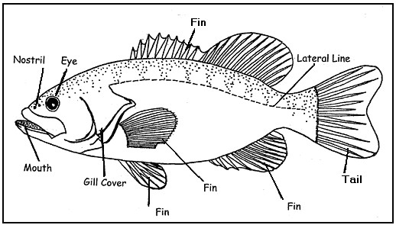

**Functions of different parts of a fish.**

1. Nostrils are for smelling.
2. Lateral line is for detecting movement in water.
3. Fins are for balancing in water.
4. Scales protect the body of a fish.
5. Gill cover protects the gills.
6. A fish uses gills for breathing.

**Uses of fish to man**

1. Fish provide us with meat.
2. Fish are sold to get money.
3. Some fish are used as medicine e.g.silver fish and herrings.
4. Fish bones are used for making glue.

**General uses of animals**

1. Some animals provide us with meat
2. Some animals provide us with milk.
3. Man gets hide and skin from animals
4. Animals like sheep and rabbits provide us with wool.
5. Some animals are used for protection e.g. dog.
6. Some animals are used for transport e.g. donkey, camel, horse.
7. Man gets money after selling some animals at home.
8. The bones and horns of animals are used for making buttons, glue and fertilizers
9. Man gets local medicine from some animals
10. The feathers of domestic birds is used to stuff pillows and mattresses and decoration. **Plants in our environment**

**Plants**

Plants are divided in two main groups namely; a) Flowering plants

b) Non flowering plants.

**Non flowering plants.**

Non flowering plants are those that do not bear flowers.

**Examples of non- flowering plants** a) Mosses

1. Lichens
2. Algae
3. Fern

**Fungi kingdom.**

Fungi are not plants because they do not have chlorophyll.

**Examples of fungi are:** a) Mushrooms.

1. Toadstools.
2. Puff balls.
3. Oysters.

**Parts of a mushroom.**

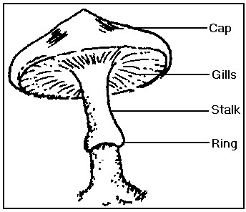

* 1. Mushrooms reproduce by the use of spores.
  2. Spores are produced and stored in the gills of a mushroom.

**Uses of mushrooms**

* 1. Mushrooms are used as food.
  2. Some mushrooms are used as medicine.
  3. Mushrooms are used in decomposing of matter

**Flowering plants**

1. These are plants, which bear flowers.
2. They usually reproduce by means of seeds.
3. A typical flowering plant has two systems:
   1. Root system
   2. Shoot system.

**Examples of flowering plants are;**

* 1. Beans
  2. Peas
  3. Groundnuts
  4. Tomatoes

**Parts of a flowering plant.**

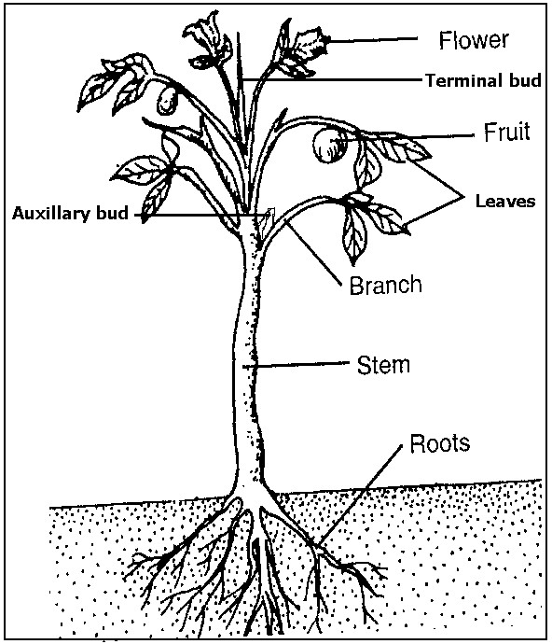

Flowering plants have two main systems a. The shoot systems

b. The root system.

**Shoot system** The Shoot system is the part of a plant that grows above the ground level.

**Parts of the shoot system** a. The Stem

* 1. The leaves
  2. The flowers
  3. Auxiliary bud
  4. Terminal buds

**The root system.**

The Shoot system is the part of a plant that grows above the ground level.

**Parts of the root system** a. Main root and

* 1. The lateral roots.
  2. Root hairs

**Parts of a leaf.**

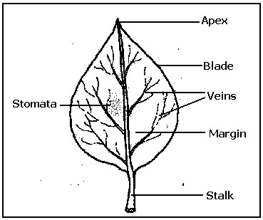

**Leaf venation**

1. Leaf venation is the arrangement of vein in a leaf.
2. There are two types of leaf venation
   1. Net venation
   2. Parallel venation.

**Drawing of a leaf showing net venation**

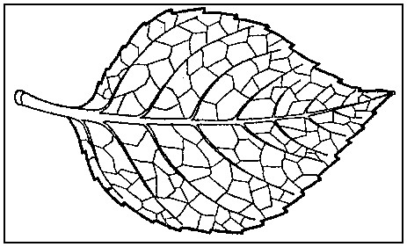

**Examples of leaves with net venation are:-**

1. Mango
2. Guava leaves
3. Bean
4. Peas leaves.

**Drawing of a leaf showing parallel venation**.

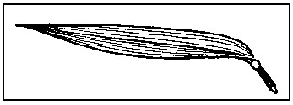

**Examples of leaves with parallel veins**

1. Millet d) Rice
2. Sorghum e) Oats
3. Maize f) Grass.

**Types of leaves**

There are two types of leaves namely:a) Simple leaves

b) Compound leaves.

**Simple leaves** A Simple leaf is a leaf with only one stalk.

**Structures of different simple leaves**

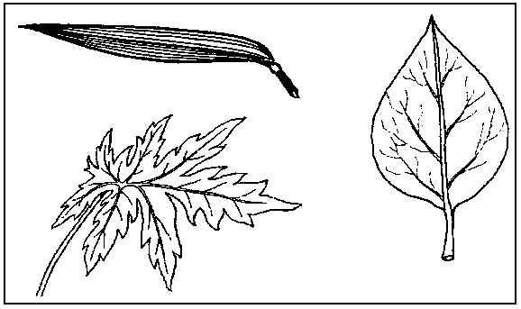

**Examples of Simple leaves are:** a) Mango leaves

1. Cassava leaves
2. Potato leaves
3. Guava leaves.

**Compound leaves**

1. A compound leaf is a leaf that has many other small leaf stalks on the main stalk.
2. It has completely separate parts called leaf lets.

**Diagrams of different compound leaves.**

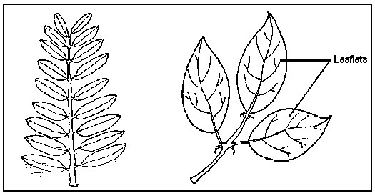

**Examples of compound leaves:** a) Bean leaves

* 1. Acacia
  2. Peas leaves
  3. Jacaranda.

**Uses of leaves to plants (Functions of leaves)** a) Some leaves store food.

* 1. Leaves make food for the plant.
  2. Plant use leaves for breathing
  3. Plants use leaves to release excess water. **Uses of leaves to man**.
  4. Local medicine is got from some leaves.
  5. Some leaves are a source of food to man.
  6. Some leaves are used for roofing and craft. **Photosynthesis**
  7. Photosynthesis is a process by which plants make their own food.
  8. Photosynthesis takes place in green parts of a plant.
  9. The green coloring matter, found in a plant leaves is called chlorophyll.

**Conditions necessary for photosynthesis to take place are:** a) Chlorophyll

* 1. Carbondioxide
  2. Water
  3. Sunlight **Note.**

The function of chlorophyll is to trap light energy from the sun.

## Parts of a root

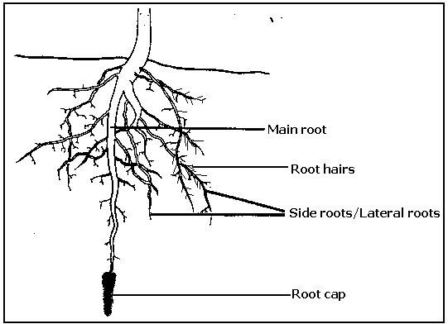

**Note**

1. A root cap protects the root as it grows.
2. Root hairs absorb water and mineral salts from the soil.

**Types of roots** Some types of roots are: a. Tap root

1. Prop roots
2. Fibrous roots
3. Adventitious roots.

**Tap root**

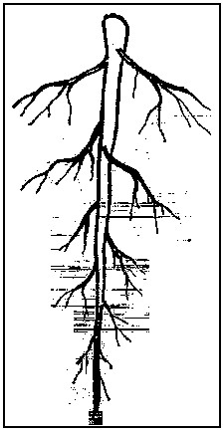

**Examples of plants with tap roots are:** a) Jack fruit

1. Mango plant
2. Paw paw plant. **Prop roots**

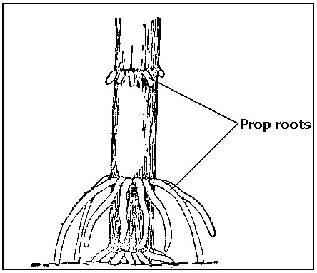

**Examples of plants with prop roots are:** a) Maize

1. Sugar cane
2. Sorghum

**Fibrous roots**

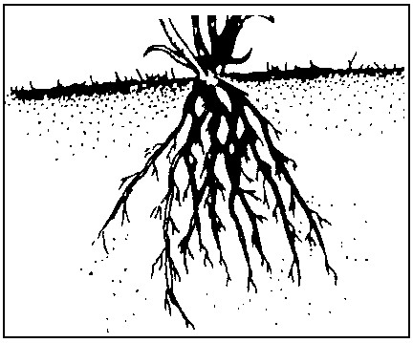

**Examples of plant with fibrous roots are**: a) Millet

c) Grass

b) Rice

**Adventitious roots**

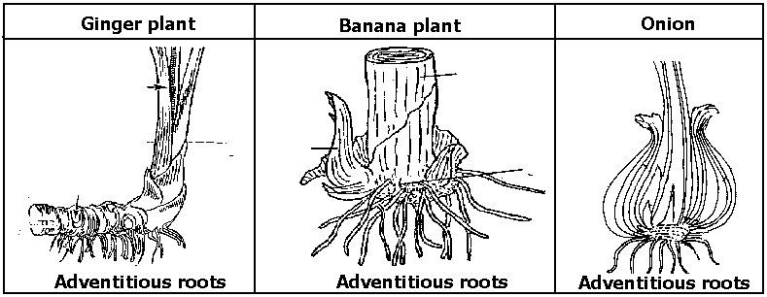

**Examples of plants with adventitious roots are:** a) Onions

1. Banana
2. Garlic
3. Ginger

**Uses of roots to plants**

1. Roots hold a plant firmly to the ground.
2. Some roots store food for the plants**.** e.g. cassava, Sweet potatoes, carrots.
3. Roots absorb (suck) water from the ground for the plant.

**Uses of roots to man.**

1. Some roots are eaten by man.
2. Man gets local medicine from some roots.
3. Man can get money from selling local medicine

**STEMS**

There are many stems. Some of them are: a) Weak stems

b) Upright or erect stems.

**An example of an upright (erect) Stem**

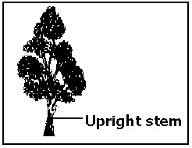

**Examples of weak stems**

1. Yams
2. Vanilla
3. Passion fruits.

**Weak stem climb other by:**a) Twining

1. Using tendril
2. Using hooks and thorns.

**Twining**

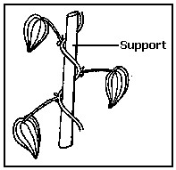

**Examples of plants that twin are**

1. Yams
2. Vanilla
3. Some beans.

**Tendrils**

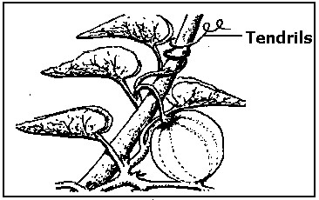

**Examples of plants with tendrils are:**a) Passion fruits

1. Pumpkins
2. Peas

**Hooks or thorns**

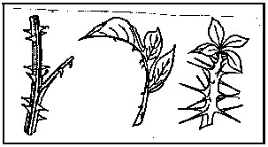

**Examples of plants with hooks or thorns are:**

1. Rose plant
2. Bougainvillea

**Reasons for climbing others plants to get enough sun** a) To get enough sunlight.

1. For support.
2. For protection against strong wind.

**THE FLOWER**

A flower is a reproductive part of a plant

**Parts of a flower**

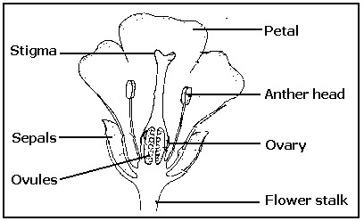

**Functions of different parts of a flower.** a) Petals attract pollinators.

1. Stigma receives pollen grains.
2. Anther heads Produce and store pollen grains.
3. Sepal protects the flower when it is still young.
4. Ovules grow into seeds after fertilization.
5. Ovary develops into a fruit after fertilization.

**Note** Fertilization is the union of female and male reproductive cells.

**Functions of a flower to a plant**

1. A flower is a reproductive part of a plant.
2. A flower produces fruits.

**Uses of flower to man**

1. Flowers with a strong smell are used for making perfumes.
2. Flowers are used for making dyes.
3. Flowers are used as gifts.
4. Some flowers are edible. (Cauli flowers, broccoli)

**Common names of flowers** a) Sun flower

1. Rose flower
2. Orchids
3. Daffodils
4. Snowdrops
5. Daisy

**SEEDS** A seed is a mature ovule.

**Types of seeds**

There are two types of seeds namely a) Monocotyledonous seeds)

d) Dicotyledonous seeds (have 2 cotyledons)

**Monocotyledonous seeds**

These are seeds that have one cotyledon

**Examples of seeds with one cotyledon are**: a) Maize

1. Oats
2. Millet
3. Barley
4. Wheat
5. Sorghum
6. Rice

**Dicotyledonous seeds**

These are seeds that have two cotyledons.

**Examples of seeds with two cotyledons are**: a) Beans

1. Soya
2. Peas
3. Groundnuts.

**External part of a bean seed.**

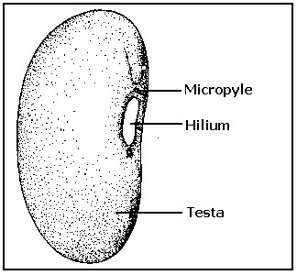

**Functions (uses) of these parts.**

1. Micropyle Lets in water and air during germination.
2. Testa Protects the inside parts of a seed
3. Hilium Scar that is left where the seed was attached to the pod.

**Internal parts of a bean seed.**

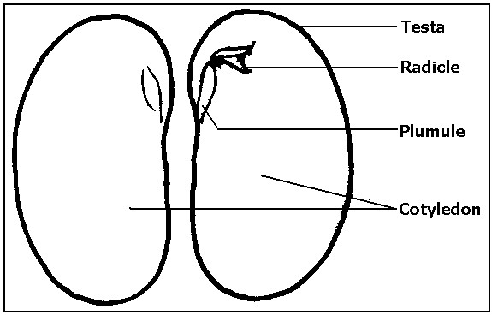

**Note:**

The plumule and radicle form the **embryo**.

**Functions of these parts.**

1. Cotyledon store food for the embryo.
2. Plumule becomes the root system after germination
3. Radicle becomes the root system after germination.
4. Embryo grows into a seedling.

**Parts of a maize seed**

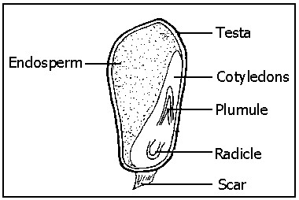

**Functions of these parts**

* 1. Testa Protects the inside parts of the seed.
  2. Endosperm stores food.
  3. Cotyledons passes food from the endosperm to the embryo.
  4. Scar It is the point of attachment to the cob.
  5. Plumule becomes the shoot system.
  6. Radicle becomes the root system after germination.

**Germination.**

1. It is a process through which a seed grows into a seedling.
2. A seedling is a young plant.

**Types of germination** a) Epigeal germination

b) Hypogeal germination.

**An experiment**: Growing bean and maize seeds to observe the growth.

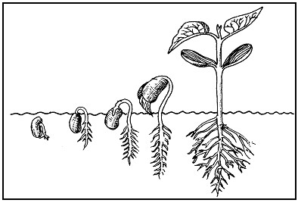

**Epigeal germination.**

This is the type of germination in which the cotyledons appear above the ground level.

**Illustration of epigeal germination.**

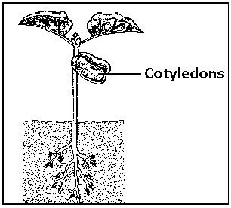

The radicle comes out first to absorb water for the embryo.

**Examples of seeds that undergo epigeal germination** a) Beans

1. Apples
2. Peas
3. Jackfruit
4. Groundnuts
5. Mango.

**Note**:

All dicotyledonous plants undergo epigeal germination.

**Hypogeal germination.**

Is the type of germination in which the cotyledon remains below the ground level.

**Illustration Hypogeal germination.**

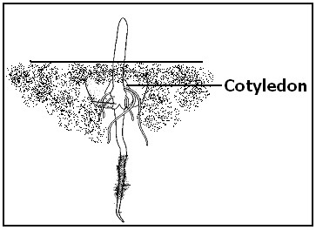

**Examples of seeds that undergo the hypogeal germination.** a) Barley

1. Wheat
2. Oats
3. Millet **Note:**
4. Rice All monocotyledonous seed undergo hypogeal germination.

**Condition for germination** a) Water

1. Oxygen
2. Warmth

**Controlled experiment showing the conditions of germination.**

## a b c

1. Has warmth, water and Oxygen so the seed will germinate.
2. Has oxygen, warmth, without water the seed will not germinate.
3. Has water, warmth without oxygen the seed will not germinate.

**Difference between monocots and dicots.**

|  |  |  |  |
| --- | --- | --- | --- |
|  | **Monocots** |  | **Dicots** |
| a | Have one cotyledon | a | Have two cotyledons |
| b | Often undergo hypogeal germination | b | Undergo epigeal germination |
| c | Have parallel leaf venation | c | Have net venation |
| d | Most have fibrous root system. | d | Most have tap roots systems |

**Care for crops.**

In the care for crops the following activities are involved.

1. Pruning
2. Weeding
3. Spraying
4. Thinning

**Spraying**

1. Crops should be spayed using pesticides
2. Pesticides are chemicals used to kill pests.
3. Spraying help to control pests and crop diseases.

**Weeding**

1. Weeding is a practice of removing weeds from a garden.
2. Weeds are unwanted plants in the garden.
3. Weeding helps to reduce the competition between crops and weeds for food, water and sunlight.

**Pruning**

1. It’s a practice of removing some branches and leaves from the plants.
2. Pruning helps the plants to grow to the required shape and height.

**Thinning**

1. It is a practice of removing some crops from where they are over crowded.
2. Thinning reduces the competition amongst the crops for food, water and sunlight.

**GROWING CROPS**

**Garden tools.**

Small-scale farmers use simple tools like shown in the diagrams below;

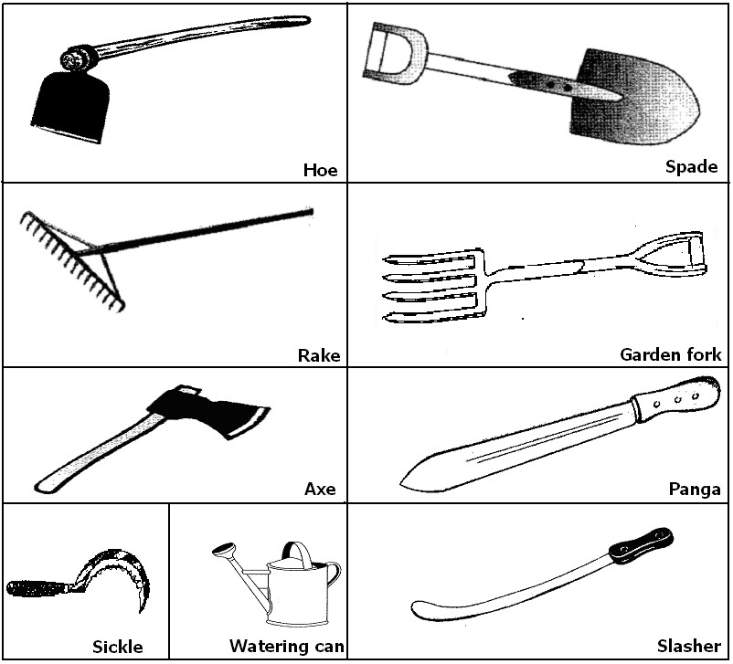

**Care for garden tools**

To make sure that garden tools are properly cared for we should :a) Give each tool the right purpose for its design when using it.

* 1. Remove the soil in tools after use.
  2. Keep the tools in dry clean and safe stores.
  3. Grease, oil or paint the tools to prevent rusting.
  4. Sharpen the tools used for cutting.

**A School garden**

* 1. A school garden is a small area on which fruits, vegetables or flowers are grown.
  2. Vegetables and fruits are nutritious.
  3. To make a garden you must have a plot of land.

## Selecting a good site for a school garden

1. When choosing a site for a school garden, one should consider the following:-
   1. The garden should be near the school.
   2. It should be near the water source.
   3. It should be near a road.
   4. It should have a good (fertile) soil.
   5. It should be on a good slope.
   6. It should be exposed to sunlight.
2. However gardens should not be :-
   1. Near big bushes.
   2. Under big trees.
   3. In rocky places.
   4. In steep slopes.
   5. In swampy areas.
   6. Expose to strong wind.
   7. Inside roofed building.
   8. Frequented by people or livestock.

**How to construct a garden** a) Clear the site by

* 1. Cutting down trees ii) Removing big stones iii) Cutting grass and bushes.
  2. Measure the site to get the outline of the garden.
  3. Divide the garden into small plots for different crops.
  4. Make paths between the plots.
  5. Build a fence around the garden to prevent intruders like thieves, animals, etc.

## A sample of constructed gardens

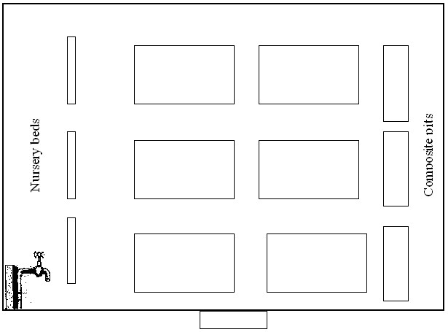

**Importance of a school garden.**

1. A school garden provides the members of the school with food.
2. Children learn to dig.
3. It can generate income for the school.
4. Children learn more about the soil and the plants.

**Planting:**

1. Some crops are grown in nursery beds.
2. A nursery bed is a small plant where seedlings are given close attention (proper care)
3. Seedlings are young plant in a nursery bed.
4. Seedlings will be transplanted to the main garden.
5. Trans planting is the transfer of seedlings from the nursery bed to a prepared garden.

**Example of crops planted in a nursery bed.** a) Carrots

* 1. Onion
  2. Rice
  3. Cabbage
  4. Cucumber
  5. Cauliflower.
  6. Tomatoes
  7. Egg plants **Methods of Planting**

1. **Row planting:**
   1. method of planting crops in lines.

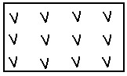

1. **Broad casting.**
   1. method of sowing seeds randomly.

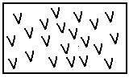

**Common groups of crop:** a) Fruits

* 1. Cereal crop
  2. Leguminous crops.
  3. Root crops
  4. Vegetable crop

**Examples of fruits**

* 1. Mango
  2. Passion fruit
  3. Watermelons
  4. Avocados
  5. Orange
  6. Pineapple.

**Examples of root crops** a) Cassava

* 1. Carrots
  2. Sweet potatoes
  3. Yams.

**Examples of vegetable crops.** a) Onion

* 1. Cabbage
  2. Carrot
  3. Tomatoes
  4. Lettuce
  5. Spinach..

**Examples of Cereal crops.** a) Maize

* 1. Sorghum
  2. 3Wheat
  3. Rice
  4. Millet
  5. Barley.

**Leguminous Crops.**

1. These are crops that have root nodules.
2. Root nodules contain bacteria that fix nitrogen in the soil.
3. Legume plants therefore help in improving the fertility of soil by adding nitrogen to the soil.

**The root of a legume crop.**

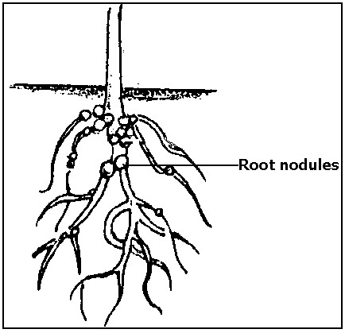

**Examples of legumes** a) Beans

* 1. Peas
  2. Groundnuts.
  3. Soya beans.

**Crop disease**

Crop diseases are usually caused by:-

* 1. Fungi
  2. Bacteria
  3. Nematodes
  4. Viruses
  5. Lack of nutrients

**Examples of crop diseases and the crops they affect.**

|  |  |  |  |
| --- | --- | --- | --- |
|  | **Disease** |  | **Crop it attacks** |
| a | Mosaic | a | Cassava |
| b | Panama | b | Banana |
| c | Blast | c | Rice |
| d | Rust | d | Maize |
| e | Rosette | e | Groundnuts |

**Pests**.

A pest is an animal that destroys crops.

**Examples of pests;** a) Monkeys

1. Man
2. Birds
3. Weevils
4. Rats, e.t.c

**Control of crop pests**

1. Using crop rotation.
2. Planting resistant varieties.
3. Spraying.
4. Rearing natural enemies to eat of the pest.
5. Using traps.
6. Using scarecrows.

**Crop rotation**

Crop rotation is the growing of different crops in the same piece of land seasonally.

**Illustration of crop rotation.**

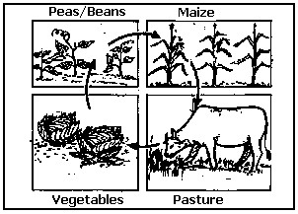

**Importance of crop rotation**

1. Crop rotation helps in controlling pests and diseases.
2. It helps in maintaining soil fertility.
3. The fallow (rest) period helps to reduce soil erosion.

**Note**:

1. Soil fertility is the ability of soil to support plant growth.
2. Soil erosion is the removal of topsoil.

**What to consider during crop rotation.**

1. Crops with Similar root system should not follow one another because the following crop will not get enough nutrients as they feed with in the same soil level.

**Examples of crops with the same root system are:**a) Millet

* 1. Sorghum
  2. Maize
  3. Rice.

1. Crops that are affected by similar pests should not follow one another because the same pest will affect the crop that follows.

**Examples of crops that can be affected by the same pest are:**a) Cassava.

* 1. Sweet potatoes.
  2. Irish potatoes.

1. Crops that are affected by similar diseases should not follow one another because the same disease will affect the crop that follows

**Examples of crops that can be affected by similar disease are:**a) Egg plants.

* 1. Tomatoes.

## Note

1. Legumes should be included in the rotation because they improve on the soil fertility byadding nitrogen to the soil.
2. A fallow period should be included in the rotation because it enables the soil to regain its fertility. (A fallow period is the rest period given to land)

**How to rotate crops in the garden;**

We should check to see that:-

1. Deep-rooted crops should not follow each other.
2. Shallow –rooted crops should not follow each other.
3. Heavy feeders follow light feeders.
4. Heavy feeders follow legumes.

**Harvesting of vegetables.**

Harvesting is the practice of removing ripe or ready crops from the garden and taking them home.

**Methods of harvesting crops**.

Different crops are harvested in different ways depending on the type of crop.

Crops can be harvested through: a) Uprooting.

1. Cutting.
2. Plucking.

**Crops harvested by uprooting** a) Cassava.

1. Potatoes.
2. Other uprooted crops are groundnuts and carrots.

**Crops harvested by cutting.** a) Cabbages.

1. Sorghum.
2. Millet.
3. Wheat.
4. Rice.

**Crops harvested by plucking.** a) Egg plant.

1. Cucumber.
2. Pumpkins.
3. Amaranthus [dodo].
4. Tomatoes. **N.B**
5. When harvesting vegetables make sure that:-
   1. The vegetables are ready.
   2. The proper method is used on a crop.
   3. harvest at the right time.
6. The best season for harvesting crops is dry season because there is enough sunshine to dry the crops.

**Storage and marketing of vegetables**

1. Vegetables cannot stay for a long time after harvesting because they rot very fast.
2. They can be kept in sacks, boxes and baskets for a short time. For these reasons, vegetables should be:1. Used immediately after harvest.
   1. Sold immediately after harvest.
   2. Dried if they can be dried.

**Vegetables that can be dried and stored** a) Peas.

1. Beans
2. Simsim.
3. Cucumber.
4. Ground nuts.

**Importance of growing enough food in the family**. a) To guard against food shortage.

b) We can sell the excess food to get money.

## P.3 LITERACY 1A LESSON NOTES TERM III

**VECTORS AND DISEASES IN OUR ENVIRONMENT**

**COMMON DISEASES**

**General causes of common diseases**

Germs cause most diseases but other factors (things) also lead to diseases.

**Other factors that may lead to cause of diseases** a) Lack of safe water

1. Poverty
2. Ignorance
3. Poor waste disposal
4. Poor feeding habits.

**TYPES OF DISEASES**

1. Non- infectious diseases
2. Infectious diseases.

**Non- infectious diseases**

1. These are diseases that don’t spread from one person to another.
2. They are not caused by germs.

**Examples of Non- infectious diseases**

* 1. Marasmus g) Asthma
  2. Cancer h) Mental illness
  3. Stroke i) Epilepsy
  4. Heart attack j) Goitre
  5. Allergy k) Sickle cells
  6. Kwashiorkor

**INFECTIOUS DISEASES**

1. These are diseases that spread from an infected person to another.
2. Infectious diseases are diseases caused by germs.

**Examples of germs are**: a) Virus

* 1. Bacteria
  2. Protozoa
  3. Fungi

**Examples of infectious diseases**

|  |  |
| --- | --- |
| a) Chicken pox | f) Measles |
| b) Tetanus | g) Whooping cough |
| c) Dysentery | h) Polio |
| d) Rabies | i) Mumps |
| e) Influenza. | J) Cholera |

**Different ways in which diseases are spread** a) Contaminated water.

1. Contaminated food.
2. Insect bite bites.
3. Animal bites.
4. Body contact
5. Contaminated air.

**Water borne diseases**

These diseases spread through drinking contaminated water.

**Examples of diseases spread through contaminated water.** a) Typhoid

1. Polio
2. Cholera
3. Diarrhoea
4. Dysentery
5. Hepatitis

**Diseases spread through body contact**

These diseases spread through getting in contact with a sick person (through touch)

**Examples are diseases spread through contact.** a) Ring worms

1. Chicken pox
2. Leprosy
3. Ebola
4. Scabies.

**Diseases spread through animal bites**

Rabies is the most common diseases spread by infected animals.

**Animals which spread rabies include**;

1. Dogs
2. Cats
3. Foxes

**Disease spread through insect bites** a) Malaria

1. Yellow fever
2. Elephantiasis
3. Diarrhoea
4. Trachoma
5. Dysentery
6. Cholera

**MALARIA**

1. It is caused by a plasmodium parasite.
2. A female anopheles mosquito spreads it.

**Signs and symptoms of malaria** a) High body temperature.

* 1. Headache.
  2. Joint pains.
  3. High fever.
  4. Vomiting.
  5. Shivering.
  6. Dizziness.
  7. General body weakness.

**Effects of Malaria**

* 1. Malaria leads to miscarriages in pregnant mother.
  2. It leads to anaemia.
  3. It can kill.

**Types of Mosquito and the diseases they spread**

|  |  |  |
| --- | --- | --- |
|  | **Mosquito** | **Disease** |
| a | Anopheles | Malaria |
| b | Culex | Elephantiasis |
| c | Aedes/Tiger | Yellow fever |

**How to control the spread of Malaria**

* 1. Clear the bushes around the compound.
  2. Drain stagnant water around the compound.
  3. Sleep under a mosquito net.
  4. Spray the house with insecticides.
  5. Pour oil on stagnant water around the compound.
  6. Rear fish in ponds.

**TRACHOMA**

1. A germ called **chlamydia** causes trachoma.
2. Trachoma spread by a housefly.

**Signs and symptoms** a) Red watery eyes.

* 1. Small pinkish itchy eyes.
  2. Pus is seen in the eyes.

**Effects of trachoma of trachoma** a) Trachoma leads to blindness.

b) Trachoma leads to scarring of the eyeball.

**How to prevent trachoma**

* 1. Always observe personal hygiene.
  2. All people staying with the infected person should be examined.
  3. A sick person should be taken to the hospital

**SLEEPING SICKNESS**

1. A trypanosoma germ causes sleeping sickness.
2. Sleeping sickness is spread by a tsetse fly.
3. A tsetse fly spreads sleeping sickness to human beings.
4. A tsetse fly spreads sleeping sickness to nagana to cattle.

**Signs and symptoms of sleeping sickness**

* 1. The person develops fever from time to time.
  2. A person feels weak.
  3. The person feels sleepy all the time (drowsy).
  4. The brain is affected.

**Effects of sleeping sickness** a) It makes a person sleepy.

* 1. If it is not treated a person may die.
  2. It affects the brain.

**How to prevent sleeping sickness** a) Avoid building near bushy areas.

* 1. Clear bushes around the compound.
  2. If any signs and symptoms are seen go for medical treatment immediately. d) Use tsetse fly traps.

**Note** A tsetse fly transmits nagana to sheep, goats, cattle etc.

**DYSENTERY**

1. Dysentery is the passing out of watery stool with blood.
2. It is caused by bacteria.
3. It is spread by houseflies and cockroaches.

**Prevention of dysentery**

* 1. Using the latrines/toilets properly.
  2. Washing hands after visiting the latrine.
  3. Using water from protected sources of water like spring wells.
  4. Boiling drinking water.
  5. Wash hands before and after a meal.
  6. Cover leftover food.
  7. Re-heating left over food.
  8. Treat drinking water using chlorine.
  9. By treating drinking water.

**DIARRHOEA**

1. Diarrhoea is the frequent passing out of watery stool (faeces)
2. Diarrhoea is a disease and a sign that shows that there is a problem in the digestive system. **Causes of diarrhoea**

Bacteria cause diarrhoea.

**How diarrhoea germs spread?**

1. Eating unwashed food (fruits)
2. Drinking contaminated water.
3. Eating contaminated food.
4. Eating with contaminated fingers.

**THE 4F’S**

The 4F’s in full is;

1. Faeces
2. Flies
3. Food
4. Fingers

**Diagram to illustrate the 4F’S**

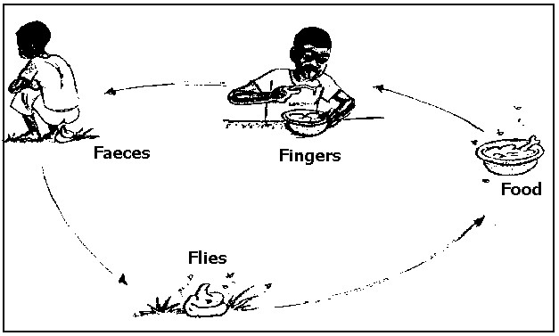

**How to control the spread of germs at difference stages of 4F’S**

**Faeces** Put all faeces in the latrine.

**Flies**

Spray the flies using insecticides.

**Food**

1. Re-heat leftover food.
2. Cover leftover food.

**Fingers**

1. Wash your hands before eating food.
2. Wash your hands after visiting the latrine.

**Effects of diarrhoea** a) Dehydration

b) Death

**The 3Ds in relation to sickness** a) Diarrhoea.

1. Dehydration.
2. Death.

**DEHYDRATION** Dehydration is a condition where the body lacks enough fluids.

**Causes of dehydration** a) Severe vomiting.

b) Severe diarrhoea.

**Signs and symptoms of dehydration** a) Sunken eyes.

1. Dry mouth.
2. Little or no sweat.
3. Sunken fontanel (soft part on the head of a baby)
4. A pinch on the skin delays to go back to normal.

**Rehydration**

1. Rehydration is the replacement of the lost water and mineral salts into the body.
2. We rehydrate the body using Oral rehydration solution.
3. Oral rehydration salts (solution) is commonly abbreviated as ORS.
4. We can make ORS locally by using salt, sugar and safe water.
5. Locally made ORS is sugar salt solution (SSS).

**How to make SSS?**

* 1. Wash your hands with safe water and soap.
  2. Measure one litre of safe water into a clean container
  3. Measure 8 leveled spoons of sugar and 1-levelled teaspoon of salt into the water
  4. Stir the mixture until all the salt and sugar dissolves.

**Prevention of Diarrhoea**

* 1. Put all faeces in the pit latrine.
  2. Boil water for drinking.
  3. Wash hands after visiting toilet/latrine.
  4. Wash fruits before eating.
  5. Cover food properly to protect it from houseflies and cockroaches.
  6. Washing hands before and after eating food.
  7. Re-heat the leftover food.

**DISEASE VECTORS**

1. Disease vectors are living organisms that spread diseases.
2. Examples of disease vectors, diseases they spread and their control.

|  |  |  |  |  |
| --- | --- | --- | --- | --- |
| **Disease vector** | | **Disease spread** |  | **Control** |
| a | Rat fleas | Bubonic plague | a) | Spray with insecticides. |
|  |  |  | b) | Kill rats using traps or poison. |
|  |  |  | c) | iii. By immunization. |
| b | Lice | Typhus fever | a)  b) | Iron your clothes  Spray the house, beds and chairs |
|  |  |  | c) | Using insecticides. |
| c | Bedbugs | Typhus fever | a)  b) | Iron your clothes  Spray the house, beds and chairs using insecticides. |
| d | Ticks | Relapsing fever | Spray with insecticides. | |
| e | Anopheles mosquito | Malaria | 1. Clear the bushes around the compound. 2. Sleep under a mosquito net. Spray with insecticides. 3. Rear fish in ponds | |
| f | Culex mosquito | Elephantiasis |
| g | Aedes/Tiger | Yellow fever |
| h | Houseflies | 1. Diarrhoea 2. Trachoma 3. iii. Dysentery | 1. Spray using insecticides. 2. Keep faeces in latrine | |

**HIV/AIDS**

1. AIDS in full is Acquired Immune Deficiency Syndrome.
2. AIDS is caused by a virus.
3. The virus that causes AIDS is called HIV.
4. HIV in full is Human Immuno-deficiency Virus.

**Ways through which AIDS spread**

* 1. Having unprotected sexual intercourse with an infected person.
  2. Transmission of infected blood.
  3. Infected mothers spread the germ to their unborn babies at birth when cutting off the umbilical cord.
  4. Sharing skin piercing instruments with an infected person.

**NOTE**

* 1. AIDS has no cure as yet, but its signs and symptoms can be treated.
  2. Anti retroviral drugs (ARVs) reduce the rate at which the viruses multiply in the body.

**Traditional practices that encourage the spread of AIDS** a) Inheritance of widows.

b) Carrying out circumcision using one cutting instrument on several people. c) Body tattooing.

d) Sharing of women.

**People at a risk of getting AIDS** a) Bar maids.

* 1. Prostitutes.
  2. Doctors that treat AIDS victims.
  3. Long distance travelers. **Effects of AIDS/HIV**
  4. Reduction in the number of people living in the country.
  5. It leads to high number of orphans.
  6. It leads to loss of skilled people.
  7. It makes the government to spend much money to care for AIDS victims. **Ways of caring for AIDS/HIV victims** a) Cooking for them food.
  8. Bathing them.
  9. Providing with a balance diet.
  10. Providing them with medicine.
  11. Washing for them clothes.

**Ways of preventing and controlling AIDS/HIV** a) Abstain from sex.

* 1. Be faithful to your partner.
  2. Use a condom when having sex.
  3. Screen blood before transfusion.
  4. Avoid sharing skin-piercing instruments with other people.
  5. Carry out blood test to know your HIV status.
  6. Take medicine (ARV’S) correctly as told by the doctor.
  7. Feed on a balanced diet always.
  8. Attend guidance and counseling meeting.

**PIASCY**

1. PIASCY in full is Presidential Initiative on AIDS Strategy for Communication to the Youth.
2. PIASCY is an effort put in by the president of Uganda to help in the prevention and control of HIV/AIDS.

**Some of the PIASCY messages are** ;

* 1. Avoid bad touches ,lonely places and gifts.
  2. Have good morals.
  3. Follow your religion to stay safe.
  4. Stay virgin.
  5. Always say no to sex.
  6. Stay in school.
  7. Boys and girls should respect each other.
  8. Know your rights.
  9. Know and observe your responsibilities.
  10. Say no to early marriage other bad cultural practices.
  11. Have good life skills.
  12. Live positively with HIV/AIDS.

**ENERGY** Energy is the ability to do work.

**Forms of energy** a) Light.

1. Heat.
2. Sound.
3. Electricity.
4. Solar energy.

**Sources of energy**

1. Natural sources.
2. Artificial sources.

**Natural sources of energy**

This is a source of energy which is made by God.

**Examples of natural sources of energy are;** a) Wind.

1. Water.
2. Sunlight and sun’s heat.
3. Firewood.

**Artificial sources of energy**

This is a source of energy which is made by man.

**Examples of artificial sources of energy are;** a) Diesel.

1. Petrol.
2. Charcoal.
3. Paraffin.
4. Electricity.
5. Fire.
6. Batteries

**USES OF EACH ENERGY RESOURCE**

**Wind**

1. Sail boats.
2. Drive windmill
3. Helps in winnowing.
4. Helps in drying clothes.

**Water**

1. Running water helps in producing hydro electricity.
2. Steam runs steam engine.

**Sun’s heat**

1. Provides vitamin D.
2. Increases temperature hence providing warmth.
3. Provides solar electricity.
4. Helps in drying clothes. **Sunlight**
5. Enables us to see.
6. Helps in photosynthesis.

**Firewood**

1. Provides heat when burnt.
2. Provides light when burnt.

**Diesel and petrol**

1. Runs car engine.
2. Runs generators.

**Paraffin, charcoal and fire**

1. Helps in heating.
2. Helps in lighting.

**Electricity**

1. Helps in lighting.
2. Runs machines in factories.

**WAYS OF SAVING ENERGY**

1. Use energy saving stoves and bulbs.
2. Switch off electrical appliances when not in use.
3. Put out burning charcoal after use.
4. Plant trees.

**Importance of saving energy**

1. It reduces wastage of resources.
2. It reduces cost on energy resources.
3. For future use.

**Dangers of energy**

1. Electricity kills people and destroys property.
2. Fire outbreak kills people and destroys property.
3. Strong wind destroys crops and property.
4. Storm can capsize boats.
5. Sun’s heat can lead into drought.

**Ways of preventing the dangers of energy**

1. Plant trees to act as windbreaks.
2. Avoid playing with fire.
3. Don’t push nails into electric sockets.
4. Don’t play with electric wires.
5. Have fire extinguisher at home to help when there is fire outbreak.
6. Make posters to sensitize people on the dangers of energy.